# Steps to create Rest webservice in Flex 11

1. Navigate to below path :

ptc\Windchill_11.0\Windchill\codebase\com\ptc\windchill\rest\rest.properties.

1. Create a new custom entry like below :

type.customWebService.rest.resources=com.cna.integration.inbound.application.CnAFlexPLMRestService

The java class mentioned above will handle your incoming web service requests.

1. Your resource class should look like this below :

package com.cna.integration.inbound.application;

import java.lang.reflect.InvocationTargetException;

import org.apache.log4j.Logger;

import javax.ws.rs.DefaultValue;

import javax.ws.rs.GET;

import javax.ws.rs.Path;

import javax.ws.rs.PathParam;

import javax.ws.rs.QueryParam;

import javax.ws.rs.core.Response;

import javax.ws.rs.POST;

import javax.ws.rs.Produces;

import javax.ws.rs.Consumes;

import javax.ws.rs.core.MediaType;

import javax.xml.bind.JAXBElement;

/**

* This is the File to fetch Webservice data.

*

* @author "true" ITCINFOTECH

* @version "true" 1.0

*/

@Path("/CNAPLMRestService")

public class CnAFlexPLMRestService {

@GET

@Produces({ MediaType.TEXT_PLAIN })

public Response getSimpleText() {

String result = "Welcome to C&A FlexPLM Inbound Webservice";

return Response.status(200).entity(result).build();

}

}

1. Compile java class and save rest.properties
2. Restart method server
3. Go to below URL in browser

<http://localhost/Windchill/servlet/rest/CNAPLMRestService>

You should see the response as

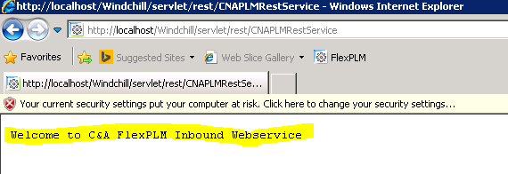

1. If you want to implement requests other than GET like POST, PATCH etc, please make sure you pass CSRF header as mentioned below, otherwise you will get an authorization issue while invoking your web service.

# Generate the CSRF Code in Server for secured Communication

## Hit the URL

<http://10.6.208.36/Windchill/servlet/rest/security/csrf>

## Get the entry key as specified below

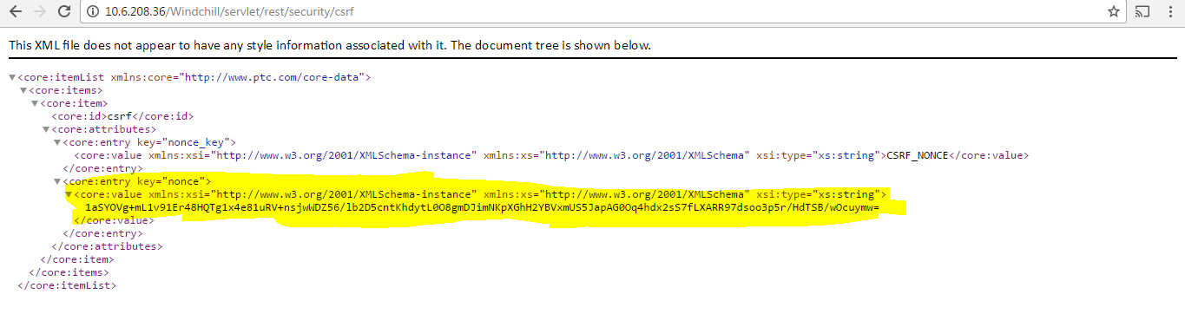

## Copy the key and Keep it Ready for Request Parameter like

|  |  |
| --- | --- |
|  |  |
| CSRF_NONCE | hJAWCh0qzSOMUq7x5fV7Qyxv9EDmN9jD3aN/OVpGrlq9Ycic/KAuYnNoiRvaFPmezNJ8fnhYgB62Y5rItaInOC8Y+hC9ZpSi88hsTk9vnBLqEJ648+gjPFJjpBPNb5M= |

While invoking web service, pass the above key in the header.

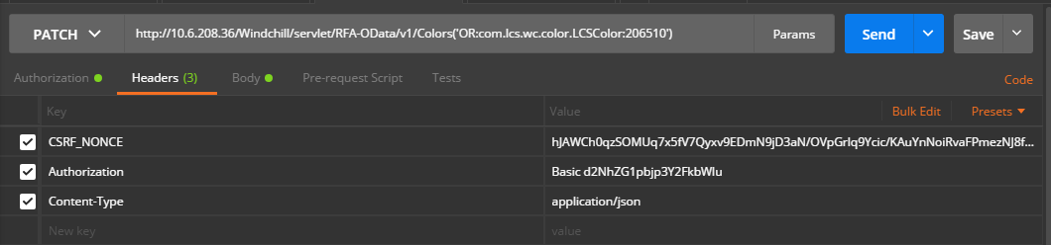

**Note:**

1. Some of the imports might not be needed.
2. Go through rest tutorials and enhance this class to accept XML or JSON and send response as XML or JSON as needed for your project.